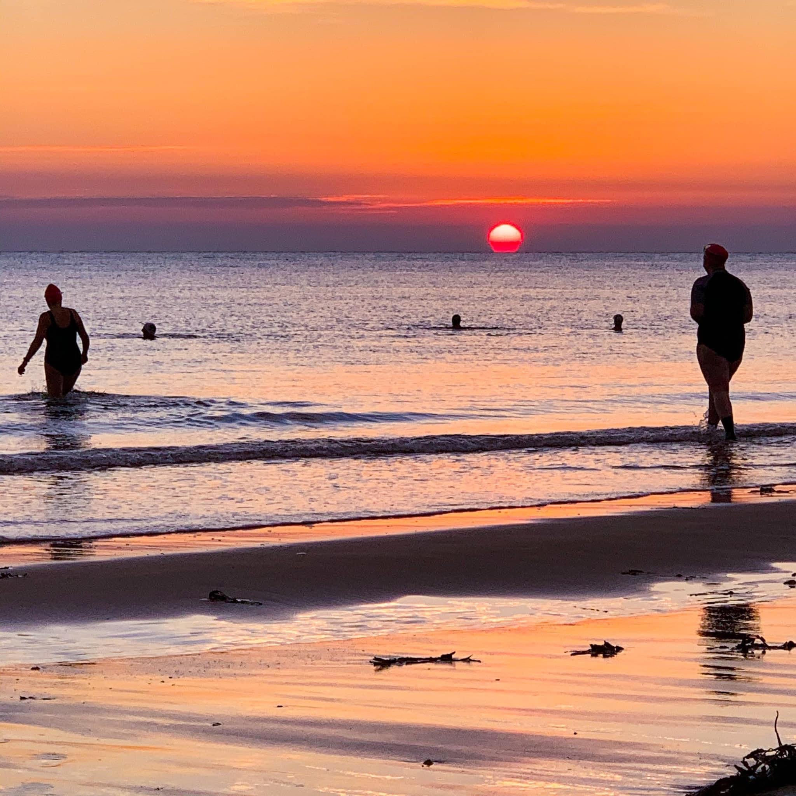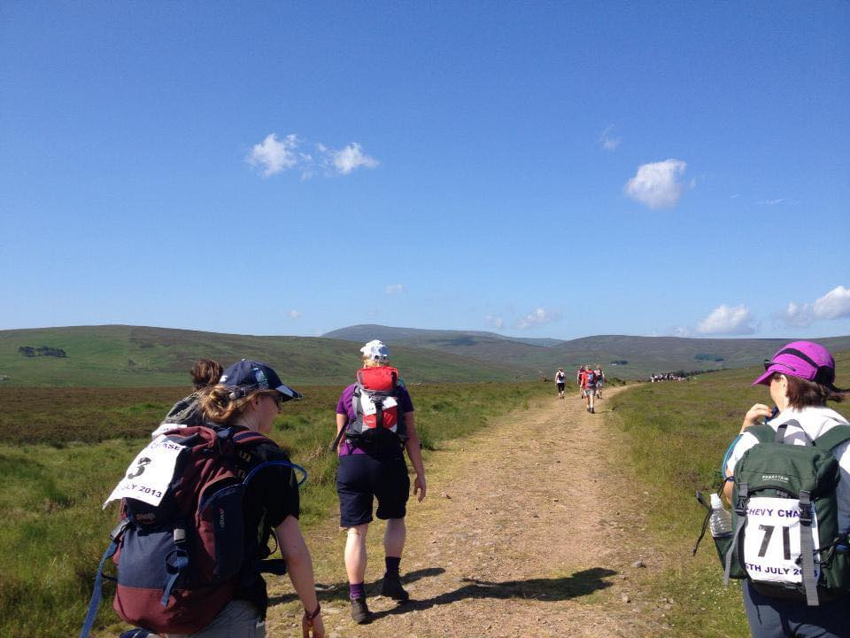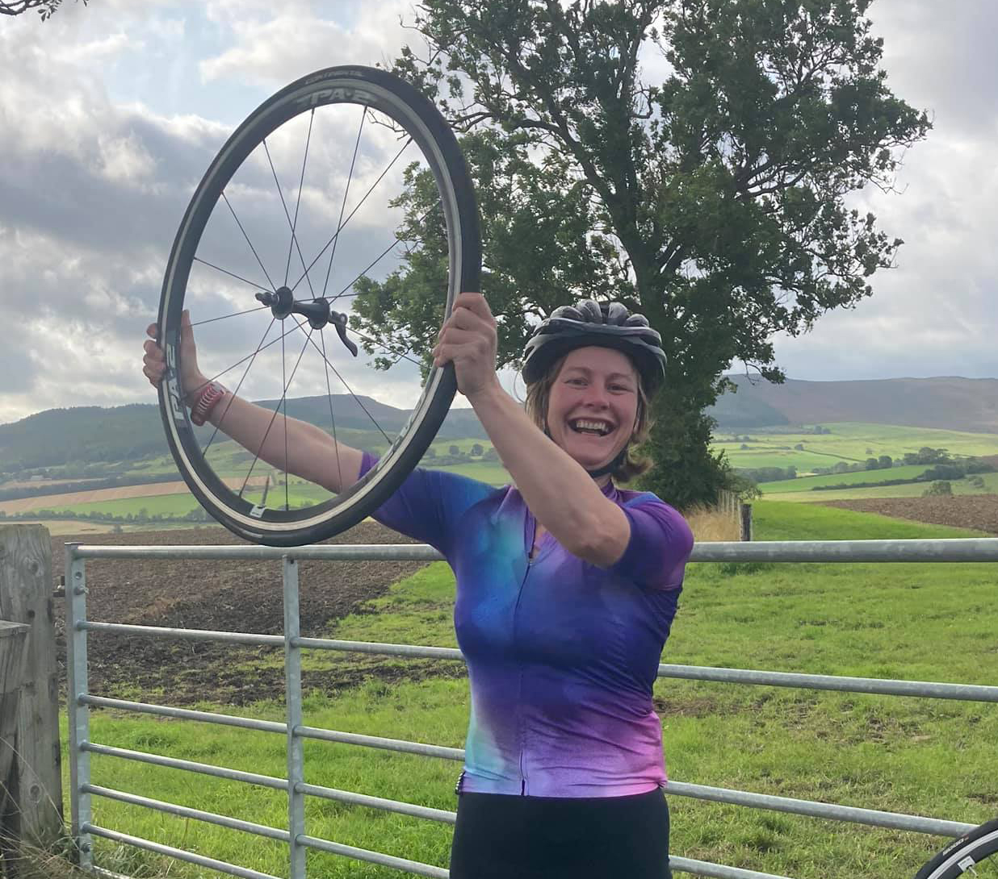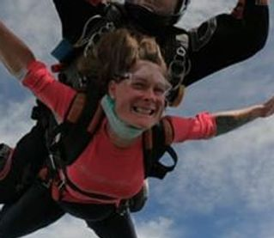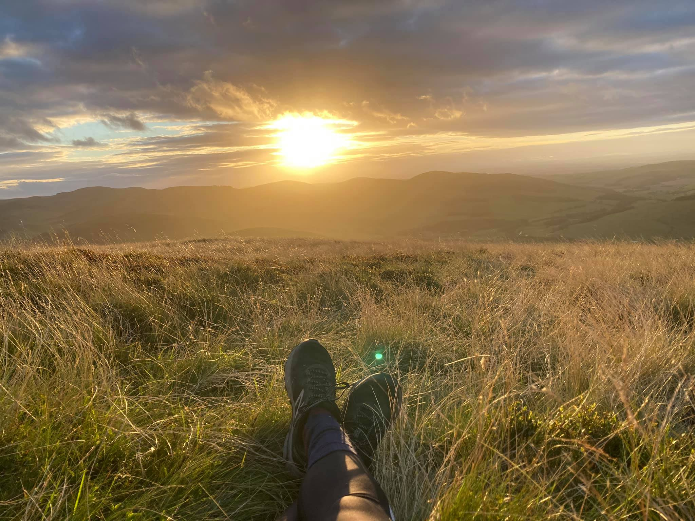

Life can seem to be much more limited in the months following a traumatic birth injury and/or getting a stoma fitted.

# For a positive view of everything you **CAN** do, check out my website and blog at **StomaChameleon.com**.

# Here you can read about my latest exploits…

# **Skydiving! Triathlons! Open Water Swimming!**

# … and you can access resources and a community of people with similar experiences for support.

# Hope to see you soon, ***Gill***

OR HAVE YOU EXPERIENCED A TRAUMATIC BIRTH?

DO YOU HAVE A STOMA?